**Hangman Game submission**

**Name : Karam Eisa**

**ID = 314987751**

**Email :** [**vpseisa1@gmail.com**](mailto:vpseisa1@gmail.com)

I started by adding a welcome splash splashscreen alert

I decided to do this game using recursion with prompts and alerts because that’s what I know.

**First step of the game:**

declared a string with the city name that will be used in the game.

Declared a temp that splits the string and replaces it with * ie [*,*,*,*,*]

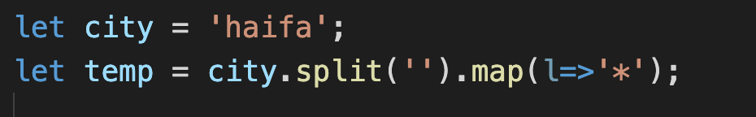

Second step :

Made a function that takes two args (answer, maxWrong)

And started with a prompt that says what is your guess?

After that I made a for loop that checks if the input from prompt is the same as the answer

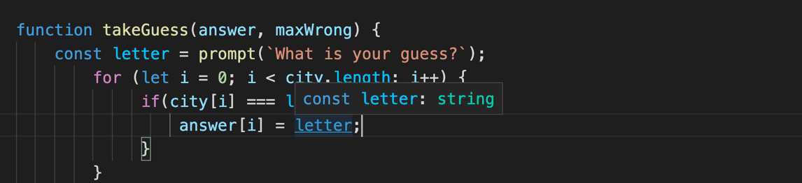

Next I made the wrong amout of answers left go down each time I make a mistake

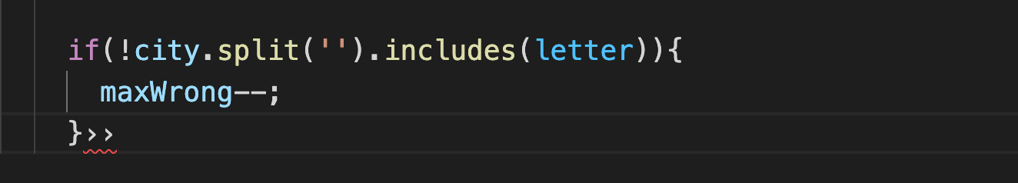

After that ,

Return an object that contain two args a and max , a is answer [*,*,*,*,*]

maxWrong is 10 at this point

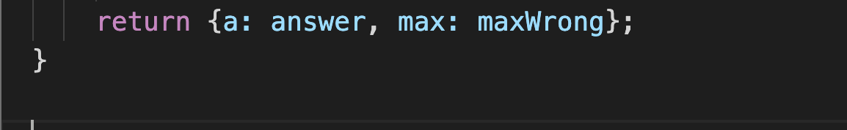

next I made a recursive function that checks if the word is complete or the guesses amount is over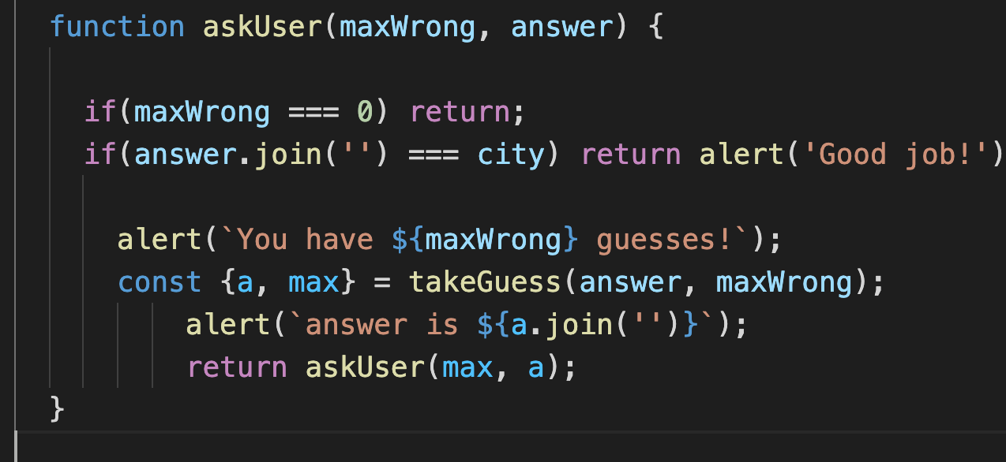

and at the end I called the function with maxWrong and temp witch took answer as temp (*****)